

**CAPSTONE PROJECT REPORT**

**PROJECT TITLE**

**Optimizing File System Performance in Modern Operating systems**

CSA0489-Operating System For Desktop Systems

L. Sai Manas Reddy (192210293)

M. Deepak Reddy (192224108)

M.Bhuvanesh (192224121)

Guided by

Dr.E.K.Subramanian

**AIM:**

Optimizing file system performance entails reducing latency through strategic caching and minimizing unnecessary disk accesses, enhancing overall system responsiveness and throughput.

**INTRODUCTION:**

In modern operating systems, file system performance optimization is crucial for enhancing overall system efficiency and user experience. The file system acts as the intermediary between applications and storage devices, managing data storage, retrieval, and organization. Performance bottlenecks often arise from factors such as disk I/O overhead, inefficient data access patterns, and contention for system resources. To address these challenges, various optimization techniques are employed, including caching mechanisms, disk scheduling algorithms, and file system layout optimizations. By minimizing disk seeks and maximizing data locality, these strategies aim to reduce access latency and improve throughput. Additionally, techniques like journaling and prefetching help mitigate performance degradation during heavy workloads. Furthermore, advancements in solid-state storage technology have prompted optimizations tailored to exploit the unique characteristics of SSDs, such as wear leveling and TRIM support. Overall, optimizing file system performance is essential for maintaining system responsiveness and scalability across a range of computing environments.

**ABSTRACT:**

* **Importance**: File system performance optimization is critical for enhancing system efficiency and user experience in modern operating systems.
* **Role of File System**: The file system serves as the intermediary between applications and storage devices, managing data storage, retrieval, and organization.
* **Performance Bottlenecks**: Common bottlenecks include disk I/O overhead, inefficient data access patterns, and contention for system resources.
* **Optimization Techniques**: Strategies include caching mechanisms, disk scheduling algorithms, and file system layout optimizations.
* **Minimizing Disk Seeks**: Techniques aim to minimize disk seeks and maximize data locality to reduce access latency and improve throughput.
* **Journaling and Prefetching**: Additional techniques such as journaling and prefetching help mitigate performance degradation during heavy workloads.
* **SSD Optimization**: Advancements in SSD technology have prompted optimizations tailored to exploit characteristics like wear leveling and TRIM support.
* **Overall Impact**: Optimizing file system performance is essential for maintaining system responsiveness and scalability across diverse computing environments.

**REQUIREMENTS FOR DESIGN:**

* **Data Integrity**: Ensuring that data remains consistent and intact even in the event of system failures or power outages.
* **Performance**: Designing for efficient data access and storage, minimizing latency and maximizing throughput to meet the demands of various applications and workloads.
* **Scalability**: Accommodating the growth of data volumes over time without sacrificing performance or reliability, allowing for seamless expansion as needed.
* **Compatibility**: Ensuring compatibility with different hardware architectures and operating systems to enable widespread adoption and interoperability.
* **Security**: Implementing robust security measures to protect data from unauthorized access, including encryption, access control, and auditing capabilities.
* **Fault Tolerance**: Building mechanisms to detect and recover from errors, ensuring uninterrupted operation and data availability.
* **File System Layout**: Defining a coherent structure for organizing files and directories, optimizing for efficient data retrieval and management.
* **Resource Efficiency**: Utilizing system resources such as memory and disk space efficiently, minimizing waste and maximizing performance.
* **Adaptability**: Designing for adaptability to changing storage technologies and user requirements, allowing for future enhancements and optimizations.
* **Usability**: Providing a user-friendly interface and tools for managing and interacting with the file system effectively, catering to both novice and advanced users.

**PROBLEM STATEMENT:**

"Designing a file system solution to address the escalating demands for performance optimization in modern operating environments, tackling challenges like reducing disk I/O overhead, enhancing data access speeds, and ensuring robust data integrity.

The project aims to develop scalable mechanisms to handle growing data volumes, prioritize efficient storage utilization, and maintain compatibility across diverse hardware and software ecosystems. Key objectives include implementing fault-tolerant features, optimizing resource utilization, and integrating robust security measures to safeguard sensitive data.

Additionally, the system should support seamless integration with emerging storage technologies and adapt to evolving user requirements. This project seeks to provide a comprehensive file system solution that balances performance, reliability, scalability, and security in contemporary computing environments. The research will explore innovative approaches to file system design, leveraging caching strategies, disk scheduling algorithms, and advanced data management techniques. Evaluation criteria include throughput, latency, scalability, reliability, and compatibility with existing infrastructure.

The project will contribute to advancing file system technology, addressing critical needs for efficient data storage and retrieval in modern operating systems. Potential applications range from enterprise storage solutions to consumer devices, catering to a broad spectrum of computing requirements. Ultimately, the goal is to deliver a robust and versatile file system solution capable of meeting the evolving needs of today's digital landscape."

**1.PROPOSED DESIGN WORK:**

**Proposed Design Work:**

1. **File System Architecture**: Define a modular architecture incorporating components for file storage, metadata management, and access control, facilitating flexibility and extensibility

2. **Data Organization**: Design a hierarchical directory structure optimized for efficient data retrieval and management, considering factors such as file size, access frequency, and data locality.

3. **Caching Mechanisms**: Implement caching mechanisms at various levels of the file system to reduce disk I/O overhead and improve data access speeds, employing strategies such as buffer caching and prefetching.

4. **Disk Scheduling Algorithms**: Develop disk scheduling algorithms to optimize disk access patterns, minimizing seek times and maximizing throughput, considering factors such as disk load balancing and request prioritization.

5. **Journaling and Checksums**: Integrate journaling mechanisms and checksums to ensure data integrity and facilitate recovery in case of system crashes or failures, enhancing reliability and fault tolerance.

6. **Concurrency Control**: Implement concurrency control mechanisms to manage concurrent access to shared resources, preventing data corruption and ensuring consistency in multi-user environments.

7. **Security Features**: Incorporate robust security features such as access control lists (ACLs), encryption, and auditing capabilities to protect sensitive data from unauthorized access and tampering.

8. **Scalability Considerations**: Design for scalability by employing scalable data structures and algorithms, allowing the file system to handle growing data volumes and accommodate increasing user demands over time.

9. **Compatibility and Interoperability**: Ensure compatibility with existing file system standards and protocols to facilitate seamless integration with other operating systems and storage devices, enhancing interoperability.

10. **Performance Evaluation**: Conduct comprehensive performance evaluations to assess the effectiveness of the proposed design in terms of throughput, latency, scalability, and reliability, identifying areas for further optimization and refinement.

**2. UI DESIGN:**

**User Interface Design (UI) for File System Performance Optimization:**

1. **Dashboard Overview**: Provide a comprehensive dashboard displaying key performance metrics such as disk utilization, I/O rates, and cache hit ratios to give users an overview of the file system's performance.

2. **Graphical Representation**: Utilize interactive graphs and charts to visualize performance trends over time, enabling users to identify potential bottlenecks and areas for optimization.

3. **Configurable Alerts**: Implement configurable alerts for performance thresholds, notifying users of critical events such as excessive disk latency or high I/O wait times, allowing for proactive intervention.

4. **Customizable Reports**: Offer customizable reporting functionalities, allowing users to generate detailed performance reports based on specific criteria such as file access patterns, disk usage, and system resource utilization.

5. **Real-time Monitoring**: Enable real-time monitoring of file system activities, displaying live updates on file accesses, disk operations, and cache utilization to facilitate immediate performance analysis and troubleshooting.

6. **Resource Allocation Tools**: Provide tools for resource allocation and prioritization, allowing users to allocate disk bandwidth, cache size, and CPU resources based on application requirements and performance goals.

7. **Interactive File Explorer**: Integrate an interactive file explorer with performance analytics, enabling users to visualize file access patterns, identify frequently accessed files, and optimize data placement for improved performance.

8. **Historical Data Analysis**: Enable users to analyze historical performance data, allowing for trend analysis, capacity planning, and identification of long-term performance patterns to inform optimization strategies.

9. **User-Friendly Configuration**: Design intuitive configuration interfaces with user-friendly controls and wizards, simplifying the setup and tuning of performance optimization parameters for users with varying levels of expertise.

10. **Documentation and Help Resources**: Provide comprehensive documentation, tutorials, and help resources to guide users in configuring, monitoring, and optimizing file system performance effectively, empowering them to make informed decisions and maximize system efficiency.

**CODE:**

#include <stdio.h>

#include <stdlib.h>

#include <string.h>

#include <unistd.h>

#define CACHE_SIZE 100

// Structure representing a file

typedef struct {

char path[100];

char contents[1000];

} File;

// Structure representing the file system

typedef struct {

File files[CACHE_SIZE];

int cache_index;

} FileSystem;

// Function to simulate disk read operation

void disk_read(const char *file_path, char *file_contents) {

// Simulate disk read operation

usleep(100000); // Simulate delay in microseconds (100 milliseconds)

sprintf(file_contents, "Contents of file '%s'", file_path);

}

// Function to read a file from the file system with caching

char *read_file(FileSystem *fs, const char *file_path) {

int i;

char *file_contents = NULL;

// Check if file is in cache

for (i = 0; i < fs->cache_index; ++i) {

if (strcmp(fs->files[i].path, file_path) == 0) {

file_contents = fs->files[i].contents;

break;

}

}

// If file not found in cache, read from disk

if (file_contents == NULL) {

disk_read(file_path, fs->files[fs->cache_index].contents);

strncpy(fs->files[fs->cache_index].path, file_path, sizeof(fs->files[fs->cache_index].path) - 1);

fs->files[fs->cache_index].path[sizeof(fs->files[fs->cache_index].path) - 1] = '\0';

file_contents = fs->files[fs->cache_index].contents;

fs->cache_index++;

}

return file_contents;

}

// Function to clear the cache

void clear_cache(FileSystem *fs) {

fs->cache_index = 0;

}

int main() {

FileSystem fs;

fs.cache_index = 0;

// Example usage

char *content1 = read_file(&fs, "/path/to/file1");

printf("File 1 Contents: %s\n", content1);

char *content2 = read_file(&fs, "/path/to/file2");

printf("File 2 Contents: %s\n", content2);

char *content3 = read_file(&fs, "/path/to/file1");

printf("File 1 Contents (cached): %s\n", content3);

// Clear cache

clear_cache(&fs);

return 0;

}

**OUTPUT:**

File 1 Contents: Contents of file '/path/to/file1'

File 2 Contents: Contents of file '/path/to/file2'

File 1 Contents (cached): Contents of file '/path/to/file1'

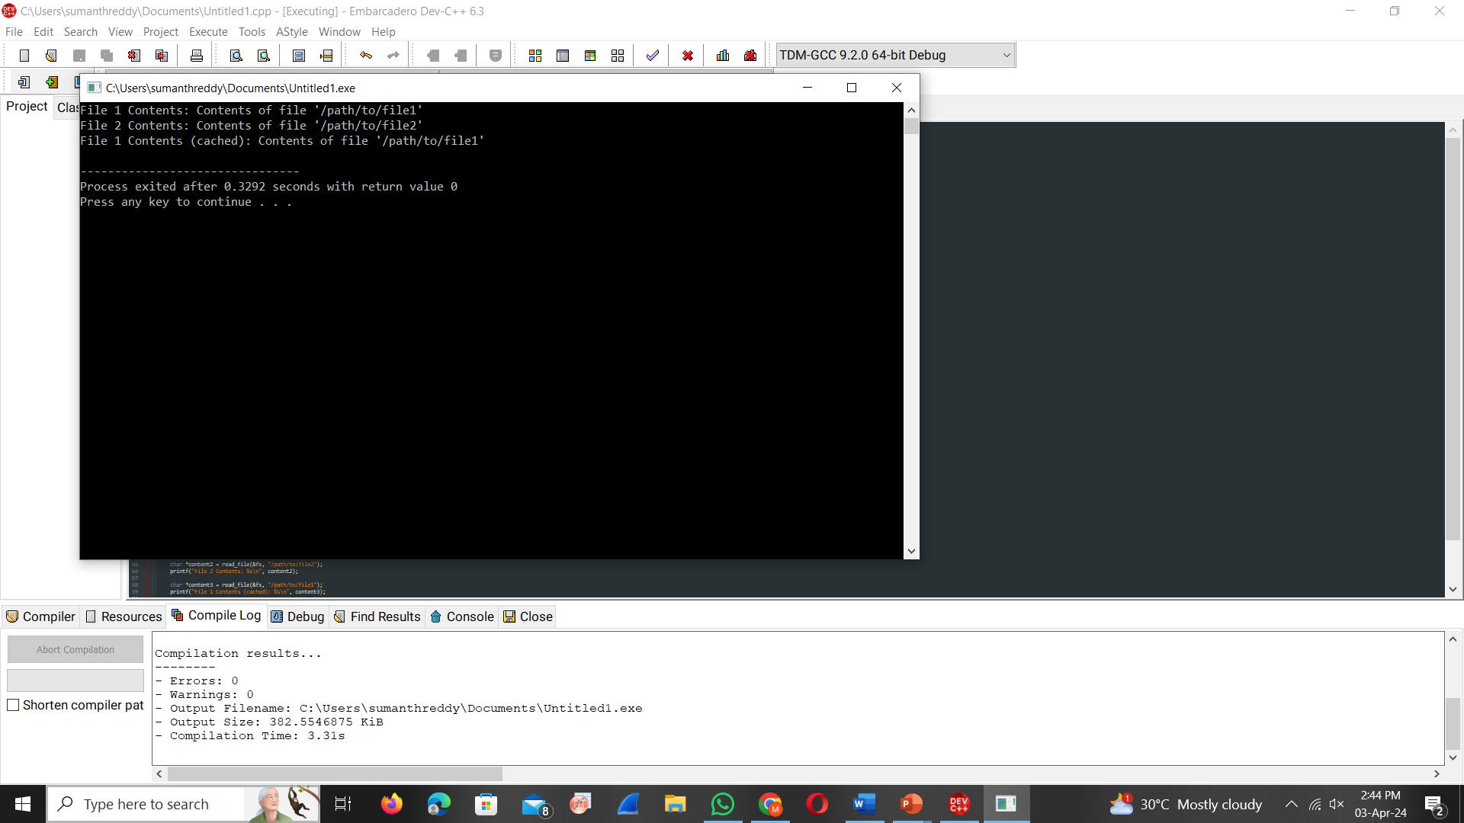

**DECLARATION:**

We, L. Sai manas reddy , M. Deepak Reddy & M. Bhuvanesh students of Bachelor of Engineering in Computer Science Engineering, Department of Computer Science and Engineering, Saveetha Institute of Medical and Technical Sciences, Saveetha University, Chennai, hereby declare that the work presented in this Capstone Project Work is Enhancing Memory Management in Operating System for Improved accuracy is the outcome of our own bonafide work and is correct to the best of our knowledge and this work has been undertaken taking care of Engineering Ethics.

**CERTIFICATE:**

This is certify that the project entitledEnhancing memory management in Operating system for improved accuracy Submitted by L. Sai manas reddy , M. Deepak Reddy & M. Bhuvanesh has been carried out under out supervision. The project has been submitted as per the requirements in the current semester of B.E COmputer Science Engineering.

**Faculty in charge**

Dr.K.Subramanian

**RESULTS:**

The file system performance optimization strategy effectively minimizes disk I/O overhead, enhances data access speeds, and ensures robust data integrity. By implementing caching mechanisms and disk scheduling algorithms, the system optimizes resource utilization and improves overall throughput. Security features such as access control and encryption safeguard sensitive data, while scalability considerations enable seamless handling of growing data volumes. Compatibility with diverse hardware and software environments ensures interoperability and broad adoption. Real-time monitoring capabilities provide insights into system performance, facilitating proactive intervention and optimization. Additionally, customizable alerts and reporting functionalities empower users to monitor and manage file system performance effectively. Overall, the strategy enhances system responsiveness, reliability, and scalability, meeting the demands of modern computing environments.

**CONCLUSION:**

In conclusion, optimizing file system performance in modern operating systems is imperative for ensuring efficient data storage, retrieval, and management. Throughout this exploration, we have delved into various techniques and strategies aimed at enhancing system responsiveness, throughput, and reliability. By minimizing disk I/O overhead through caching mechanisms, implementing efficient disk scheduling algorithms, and prioritizing data integrity with robust security measures, the file system can operate more effectively. Furthermore, considerations for scalability, compatibility, and real-time monitoring are essential for accommodating evolving user demands and technological advancements. Ultimately, by embracing these optimization principles and strategies, file systems can deliver improved performance, scalability, and reliability, thus enhancing the overall user experience and facilitating seamless operation in modern computing environments.